Welcome Back Informational

2022 - 2023

Emergency Contact Information

It is important that we have updated, emergency contact cards on file. Please update your emergency contact information. Families can complete a blue and purple card or the electronic version using the QR code below <https://forms.gle/zeV6UpCmsojq3uLd8>

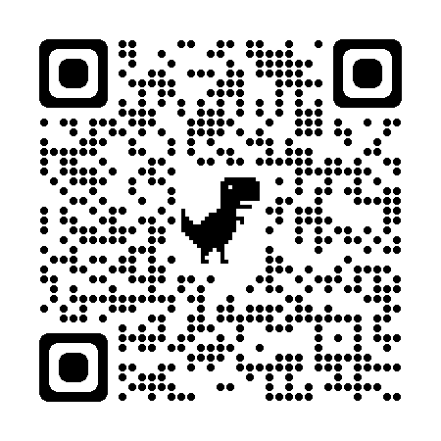

Student Behavioral Contract

Families should review and submit the attached or electronic version of the student behavior contract. Paper copies can be returned to the students’ Social Studies teacher <https://forms.gle/e6Urf3R6WQfUUnCWA>

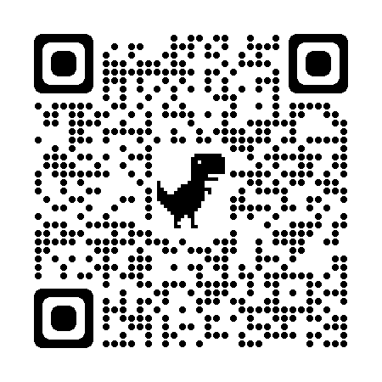

Transportation to Petrides

Metro card are distributed in the beginning of the spring, fall and summer semesters for eligible students. High school students are not eligible for Yellow Bus service.

In the morning the MTA has scheduled one S66 to make a special stop on Milford Drive from Victory Blvd and Clove Rd. The stop on Milford Drive is approximately 7:20 am. At 2:25, the MTA will provide multiple S53 & S78 for our student on Milford Drive. Students can utilize the S53 and transfer on Victory Blvd and Clove Rd where various buses and routes can be accessed. Please utilize the MTA bus timetable

for specific stops and times.  Check out the MyMTA App for up to the minute information

Student Parking on Campus

Due to the high volume of vehicular traffic and limited parking spaces, student parking is not permitted on campus during school hours. Vehicles illegally parked on the Petrides campus are subjected to towing

PSAL Sports, Clubs and Activities

Petrides has a wonderful number of clubs, teams and activities available to you as students. It is truly wonderful to watch this building come alive after school with students practicing, pursuing their interests and having fun. We are hoping that you get involved during your high school career in one or more of these wonderful clubs, teams or activities. Getting involved in a club, activity or team will not only give you the opportunity to purse your interests but also to make friends and have fun. Visit our website for more information about our clubs, teams or activities. <https://www.petridesschool.com/Page/1224>

**High School Supply List**

Each student high school schedule is unique and is based on student requests and needs. Therefore, there is not a generic supply list created before the first week of school. Each subject teacher will give a list of supplies needed during the first week of school.

Family Income Inquiry Form

**Families, regardless of income, are asked to complete a 2022-2023 Family Income Inquiry Form (formerly known as School Meals Form) so that our school can receive additional funding.**  You do not have to give any income information if you are certain that you don't qualify, however the NYC DOE asks that families submit the form.

**If families qualify according to the information submitted on the Family Income Inquiry Form (formerly known as School Meals Form), their child will be entitled to:**

* College Board and ACT fee waivers
* College application fee waivers
* A waiver of Advanced Placement (AP) exam fees (if they are waived)

<https://www.petridesschool.com/Page/1389>

Photo Consent opt-in form

We like to preserve many of the wonderful things that take place on our campus. Many of these moments are captured for staff learning opportunities and celebratory events. Included in this packet is our “Consent to be Photographed” release. We ask all families to complete this form before the first day of school. Students should return this completed form to their Social Studies teacher.

HIV/AIDS Education & Condom Availability Program

Health education that teaches responsible decision-making enables students to be more productive in school and in life. As a complement to the health education that students receive, the NYC Department of Education's HIV/AIDS education program requires a Condom Availability Program (CAP) at public high schools that can help reinforce students’ decision-making in and out of the health education classroom. According to state law, through CAP, students in grades 9-12 may request free condoms, medically accurate health information, and health referrals from trained school staff.

More information about the HIV/AIDS Education & Condom Availability Program is included in this packet. Please return the necessary documentation if you choose to opt out of this program.

Military Recruiters & Higher Education opt-out form

Federal law requires the NYC Department of Education to provide: the names, addresses, telephone numbers, and DOE student email addresses of 11th and 12th grade students to military recruiters who request this information; and/or the names, addresses, and telephone numbers of 11th and 12th grade high school students to institutions of higher education that request this information. While we are committed to protecting the confidentiality of our students, we must comply with the law.

Parents of high school students under the age of 18 and students who are 18 years of age and older may opt-out of releasing information to the military and/or institutions of higher learning. The opt out form is included in this packet. If you would like to opt out of sharing your child’s personal information with military recruiters and/or Institutions of Higher Education, you must return the signature section of this form to your child Social Studies teacher.